1 – Library Management system

- Create a class to represent a book in a Library record system.
Book
-name: String
-ID : int
-author : String
-onLoan : Boolean
(getters and setters for the above except for setOnLoan which is marked as private)
-setOnLoan
+ loan()
+ loanReturn()
- The loan method should firstly check the onLoan variable and if it is currently set to false then change it to true and confirm the to the user with an appropriate message. Otherwise message “Book currently on loan” should be displayed.
- The loanReturn method should firstly check the onLoan variable and if it is currently set to true then change it to false. A “Book returned” message should be displayed. (otherwise an error message should be display e.g. “Book not on loan”

Include a default and an argument constructor (that accepts and sets all instance variables) for the Book class.

2. Create class LibraryDesk
The class should contain the following..

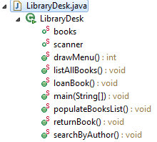
Array of Books – max limit 5

When the application starts (Main method in LibraryDesk) the following menu should be displayed.)
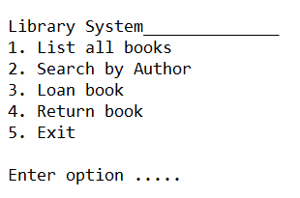
The list of books in the Library should also be populated when the application starts. Each book object should be stored as an individual element in the Books array. The books array may be declared as
and poluated using the populateBooksList() method.

Option 1 :
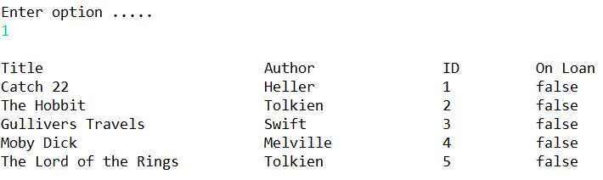

Option 2 :
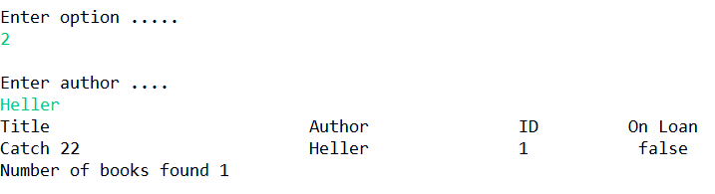

or
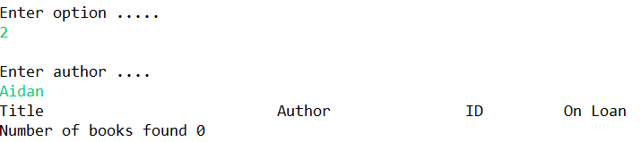

Option3

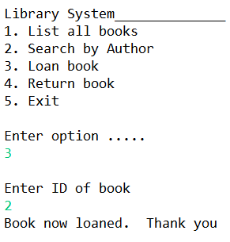 or
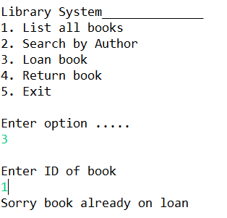or

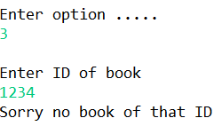

Option 4

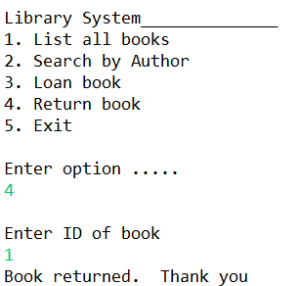 or

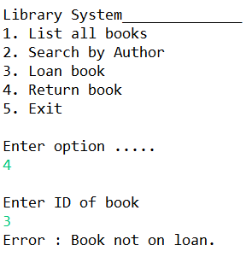 or
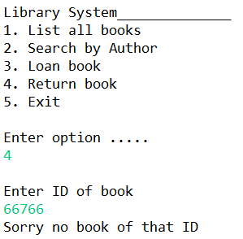

Option 5
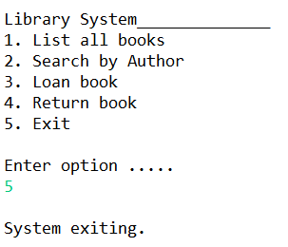

Updates …

The system owner has requested some updates.
- The system should have an option to view all on loan books.
- The system should have an option to view all books not currently on loan
- The system should have the option to search by Book Genre. E.g. Horror, Comedy, Thriller (This will require you to update the Book class with an extra field i.e. private String genre.)
- The system should have the option to search by Book Rating. E.g. 1 - 5 (This will require you to update the Book class with an extra field i.e. private int rating). The user should be able to enter the rating e.g. 4 and all books at this rating should be shown on screen.

